**Allay UI Design**

Designed by **Kiran Gunasekaran** for Allay CMPS 115

Allay uses four primary colors in its user interface design (prototype was designed using a base webpage template of 1920 x 1080).

**White Cyan Gray Black**

#ffffff #7ECFED #707070 #000000

   

**Login Page**

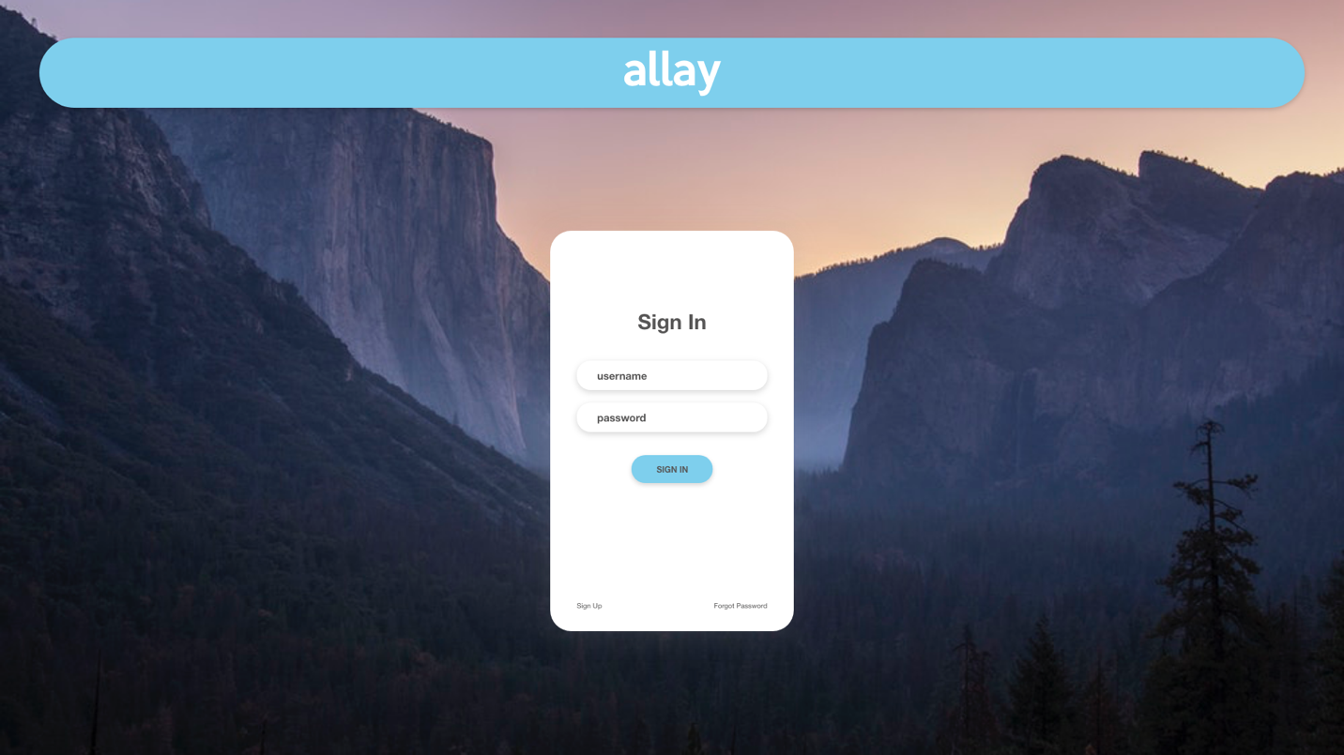

The main login page consists of three main elements

1. Title Bar
2. Login Box
3. Background image
4. **Title Bar**: The title bar main purpose is for aesthetic reasons and has no actions associated with it.



Colors used for the main bar are cyan and white.

Title Bar details:

* Hex: **#7ECFED**
* **Curved around edges**
* Dimensions:
  + Width: 1**808px**
  + Height: **100px**
  + Centered:
    - X-Axis: **56**
    - Y-Axis: **54**

Main logo details:

* Font: **Keep Calm, Regular**
  + Download link for font: <https://www.dafont.com/keep-calm.font>
* Font Size: **60**
* Hex: **#ffffff**
* Dimensions:
  + Width: **140px**
  + Height: **72px**
  + Centered:
    - X-Axis: **890**
    - Y-Axis: **68**

1. **Login Box**: The login box purpose is to allow the user to log into their account by entering their username and password.

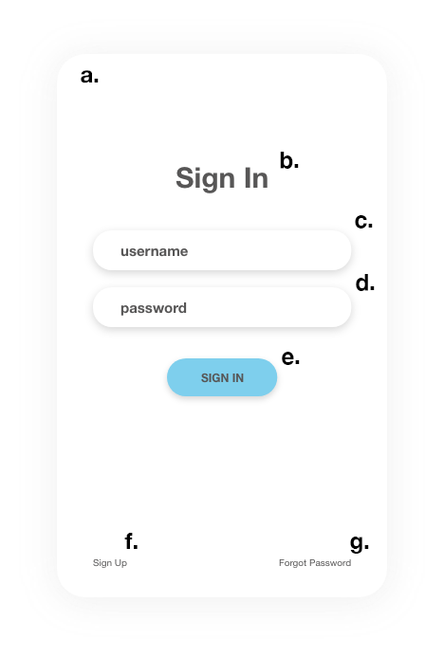

The login box consists of several element:

* 1. Login Box
     + Hex: **#ffffff**
     + Dimensions:
       1. Width: **348px**
       2. Height: **573px**
     + **Drop Shadow**
     + **Curved around edges**
     + Centered:
       1. X-Axis: **786**
       2. Y-Axis: **330**
  2. Sign in icon
     + Font: **Helvetica Neue, Bold**
     + Font Size: **30**
     + Hex**: #707070**
     + Dimensions:
       1. Width: **98px**
       2. Height: **36px**
     + Centered:
       1. X-Axis: **911**
       2. Y-Axis: **442**
  3. Username box
     + Dimensions:
       1. Width: **272px**
       2. Height: **42px**
     + Centered
       1. X-Axis: **824**
       2. Y-Axis: **516**
     + Hex: **#ffffff**
     + **Drop Shadow**
     + **Curved around edges**
  4. Password box
     + Dimensions:
       1. Width: **272px**
       2. Height: **42px**
     + Centered
       1. X-Axis: **824**
       2. Y-Axis: **576**
     + Hex: **#ffffff**
     + **Drop Shadow**
     + **Curved around edges**

**NOTE: Username Box and Password Box are 20px apart from each other**

* 1. Sign in button
     + Hex: **#7ECFED**
     + Dimensions
       1. Width: **116px**
       2. Height: **40px**
     + Centered
       1. X-Axis: **902**
       2. Y-Axis: **651**
     + **Drop Shadow**
     + **Curved around edges**
     + Inside text:
       1. Font: **Helvetica Neue, Bold**
       2. Font Size: **12**
       3. Font Style: **All Caps**
       4. Hex**: #707070**
       5. Dimensions
          1. Width: **45px**
          2. Height: **15px**
       6. Centered
          1. X-Axis: **938**
          2. Y-Axis: **664**
  2. Sign up icon
     + Hex: **#707070**
     + Font: **Helvetica Neue, Regular**
     + Font Size: **12**
     + Dimensions
       1. Width: **36px**
       2. Height: **12px**
     + Centered
       1. X-Axis: **824**
       2. Y-Axis: **860**
  3. Forgot Password icon
     + Hex: **#707070**
     + Font: **Helvetica Neue, Regular**
     + Font Size: **12**
     + Dimensions
       1. Width: **76px**
       2. Height: **12px**
     + Centered
       1. X-Axis: **1020**
       2. Y-Axis: **860**

If user enters wrong password, there should be a small text at the bottom in red that tells the User that password is incorrect and to direct them to enter correct password or click Forgot Password as shown below.

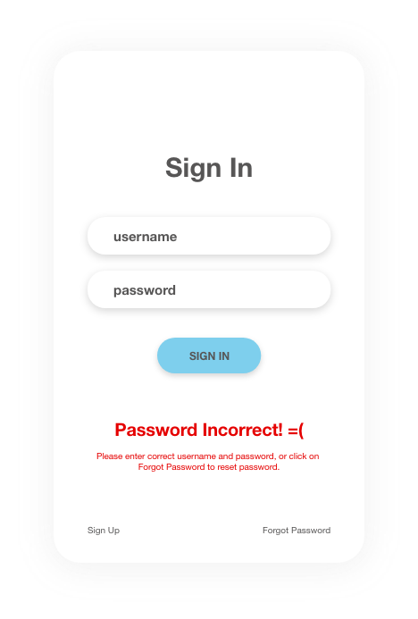

1. **Background**: The background is designed to change every time someone reloads the page, for the first two sprints we will leave it as white and eventually implement the feature where the background image updates every time reload button is hit.

**Sign Up Page**

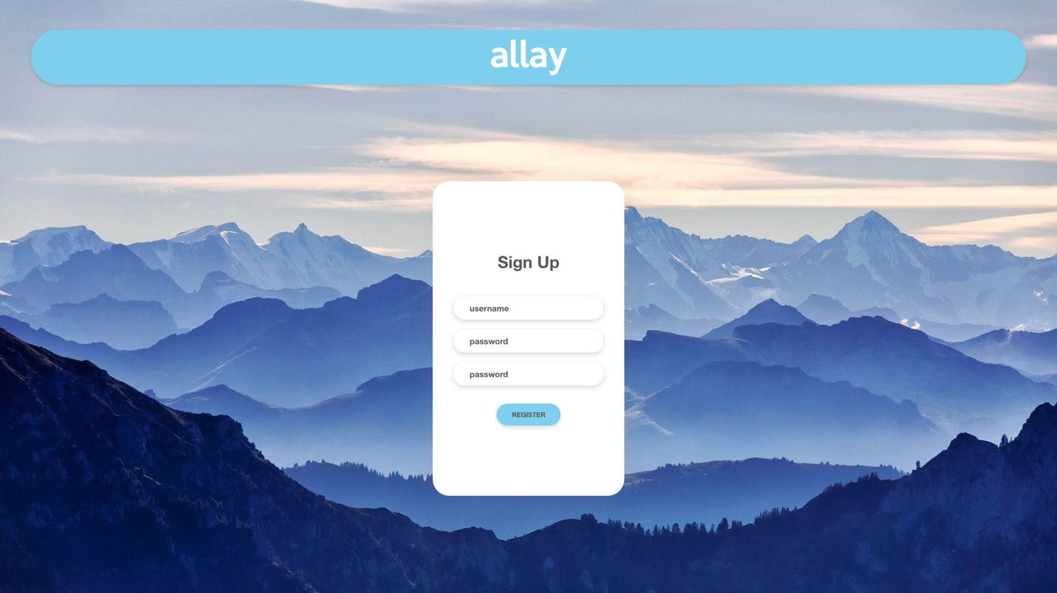

The sign-up page is basically the same as the login page, only with slight exceptions.

1. Sign In title is now Sign Up
2. There is an additional text box to re-enter password
3. SIGN IN box is now REGISTER

Also, the contents of the Login Box are now centered to the dimensions of the Login box. (Wrap the contents of the login box in a separate div and have it centered to the Login box)

**Forgot Password Page**

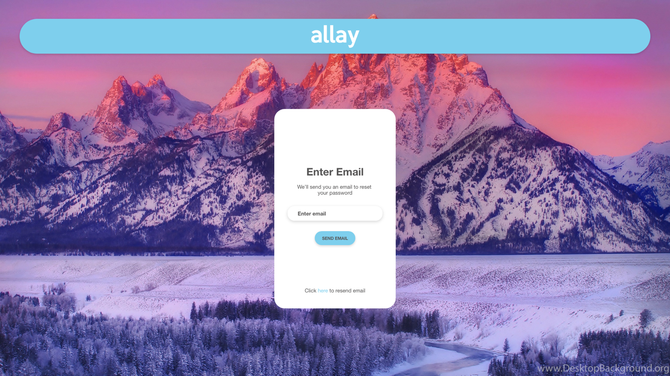

**Main Page**

